
Name: _____________________

Mathematics Essentials – Unit 1: Test 3

Mark: _____ / 47

Multiple Choice Section Marks 5

- Kate’s hourly rate of pay is $9.50 for the first 36 hours and time-and-a-half for every extra hour. How much is she paid for 41 hours?

A $389.50 B $413.25 C $460.75 D $584.25

- Dale has a salary of $48 984 p.a. His fortnightly pay is:

A $1884 B $1959.36 C $2041 D $2226.55

- Hannah receives a commission of 6.5% on all her sales. How much commission does Hannah earn in a week in which her sales total $2800?

A $182 B $232.14 C $430.77 D $1820

- Caleb receives a royalty of 15% on the market price on sales of a book he has written. If the book sells for $12.95, find Caleb’s total royalties for a period when 2180 books have been sold.

A $1882.07 B $2525.10 C $2823.10 D $4234.65

- Morgan’s local council sent a bill for water rates. It showed the following information:
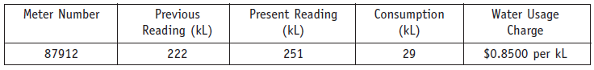

The amount Morgan will need to pay is:
A $24.65 B $188.70 C $213.35 D $246.50
Question 1 Marks 4

Calculate the area of the following shapes:

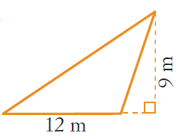 | 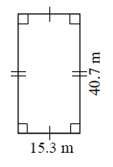 | 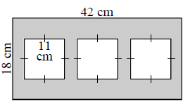  - Find the area of the shaded section

Question 2 Marks 5

- Calculate the 2.5% commission earned by a salesman on the following car sales:

- Ford Falcon worth $24,887 | - Toyota Hilux worth $56,390

- Aaron is paid a salary of $380 per week plus 5% commission on any sales over $40,000 each month. Aaron sold $68,200 worth of goods last month. How much did he earn for the month?

Question 3 Marks 2

Amanda works on Thursday evening and Saturday at her local supermarket. She is paid $8.40 per hour. This is a casual rate before deductions such as tax. On Thursday she works from 5 pm to 9.30 pm and on Saturday from 12.30 pm to 6 pm.

- How many hours does Amanda work each week?

- Calculate her weekly pay at the casual rate.

Question 4 Marks 5

Justin is 22. He works full-time as a registered plumber. Justin’s basic hourly rate of pay is $18.28.

- Justin works a 38-hour week. What is his weekly rate of pay?

- Calculate Justin’s annual salary, assuming 52 weeks in the year.

As well as paying the employee, the employer contributes 9% to the employee’s superannuation.

- Calculate the employer weekly contribution to Justin’s superannuation. Round the answer to the nearest cent.

Justin’s friend, Matthew, is also a 22 year-old registered plumber. Matthew works as a casual employee. The loading for casual employees is 20% on top of the base rate.

- What is Matthew’s hourly rate of pay? Round the answer to the nearest cent.

Question 5 Marks 7

The individual income tax rates for the 2007-2008 financial year are shown in the following table.
Tax rates 2007 - 2008
Taxable income | Tax on this income
$1 - $6,000 | Nil
$6,001 - $30,000 | 15c for each $1 over $6,000
$30,001- $75,000 | $3,600 plus 30 c for each dollar over $30,000
$75,001- $150,000 | $17,100 plus 40 c for each dollar over $75,000
$150,001and over | $47,100 plus 45 c for each dollar over $150,000
Australian Taxation Office
Use the tax table to calculate the amount of tax payable on the following taxable incomes:

- $25 000 | - $37 000 | - $150 000

Question 6 Marks 7

Mark’s normal wage is $880.80 for a 40-hour week. He worked overtime and earned $1233.12 in one week.

- Find his normal hourly rate.

- How much extra did he get for overtime?

- How many hours of overtime did he work if he was paid double-time for the overtime worked?

Question 7 Marks 2

Find the new price of the following items after the discount has been applied:

- Original price: $365  Speakers has a 25% discount   | - Original price: $240    Shoes has a 40% discount

Question 8 Marks 10

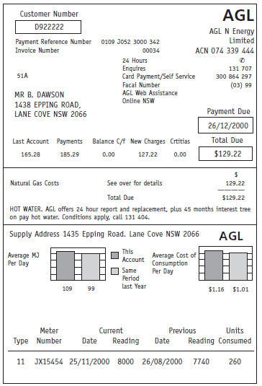
Answer the following questions in relation to the gas bill shown.

- What is the payment reference number?

- When is the payment due?

- What is the total amount payable for this bill?

- What is the difference between the total of this bill and the total of the last bill?

- What is the meter number?

- How many units were consumed?

- If 1 unit = 38.196772 megajoules (MJ), convert the gas units consumed in part F to the number of megajoules (MJ). (Answer to the nearest MJ)

- If 1 MJ is charged at the rate of 1.0595 cents, what is the total
cost of the megajoules consumed during this period?

  - How much is the supply fee? (Hint: Total Fee = Supply Fee + New Charges)

